Individual Black Forest Trifles

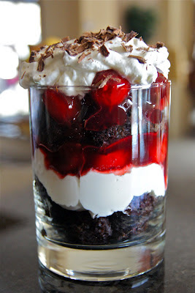
Few desserts are more elegant than an expertly assembled black forest cake. The mounds of white, fluffy whipped cream, contrasted with shards of brown chocolate and bright red maraschino cherries all make a black forest cake a dreamy sight.

The following recipe makes approximately six to eight individual trifles. You can use a chocolate cake of your choice. A huge convenience is cutting the cakes into cubes and storing them in the freezing so that they are on hand for whenever I get a craving for something sweet, which is usually quite often.

Individual Black Forest Trifles
Serves 6 to 8

INGREDIENTS
- 1 jar morelo cherries, in syrup
- 1/2 cup sugar
- 2 TBSP cherry brandy (optional)
- 2 cups heavy cream
- 1 cup confectioner's sugar
- 2 TBSP vanilla extract
- 1 pound chocolate cake of your choice, cut into 1/2" cubes
- dark chocolate shavings
- 6 to 8 3oz servings glasses

INSTRUCTIONS

1. Drain the cherries, saving the liquid and reserving the cherries separately. Add the liquid to a sauce pan, together with the cherry brandy (if using) half cup of sugar. Simmer until thickened and reduced by half. Allow to cool then combine with the reserved cherries, and set aside.

2. Whip the cream, confectioner's sugar, and vanilla together until fluffy, with stiff peaks.

3. To assemble the trifles, place about 4 cubes of cake on the bottom of each individual serving glass. Top with two tablespoons of the cherries followed by two tablespoons of whipped creamed. Repeat each layer ending with the cream. Dust the top of each trifle with chocolate chards before serving.

