7 Layer Dip Party Cups
Servings 8 cups

Ingredients
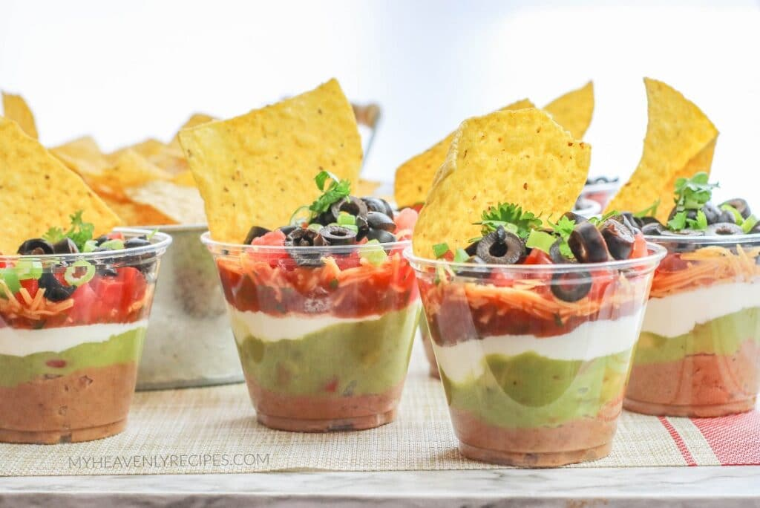
- 1 16 ounce can refried beans
- 4 tsp taco seasoning (divided – see instructions below)
- 1 cup guacamole
- 1 cup sour cream
- 1 cup salsa or pico de gallo
- 1 cup finely shredded cheddar cheese
- Green onions sliced (for garnish)
- Freshly chopped cilantro for garnish
- 2 Roma tomatoes seeded and diced
- 1 2.25 ounce can sliced black olives, drained

For serving:
- Tortilla chips
- Eight, 9 ounce clear party cups

Instructions
- In a bowl, mix together refried beans with 2 tsp taco seasoning until well blended. Transfer the refried beans to a piping bag. Snip about 1 inch from the end of the piping bag and squeeze into the bottom of the clear party cups. Smooth the top with an offset spatula.
- Next, place the guacamole into a piping bag. Snip the end and squeeze over the refried beans in each party cup. Tap the cups gently to settle the guacamole into an even layer.
- In a bowl, mix together sour cream with 2 tsp taco seasoning until well blended. Transfer the sour cream mixture to a piping bag. Snip the end and squeeze over the guacamole in each party cup. Smooth with a clean offset spatula.
- Then, place the salsa into a piping bag. Snip the end and squeeze over the sour cream in each party cup. Tap the cups gently to settle the salsa into an even layer.
- Top with cheddar cheese and garnish unless adding additional layers.
- To make seven layer cups, add a layer of diced tomato and sliced black olives before garnishing.
- Serve with tortilla chips.

